**Department of Computer Science and Engineering**

|  |  |
| --- | --- |
| **Course Code:CSE422** | **Credits:** |
| **Course Name: Artificial Intelligence** | **Prerequisite:** CSE111, CSE221 |

**Lab 06**

**Logistic Regression**

1. **Lab Overview:**

The students will learn the logistic regression analysis for the machine learning approach.

1. **Learning Objective:**
   1. How to build a model for classification using logistic regression.
2. **Lesson Fit:**

There is pre-requisite to this lab: CSE111, CSE221. You should have intensive Programming Knowledge and capability to understand algorithms.

1. **Acceptance and Evaluation**

Students will show the output using different datasets and python code. They will be marked according to their lab performance. The main evaluation criteria will be based on project report and demonstration.

1. **Learning Outcome:**

After this lab, the students will be able to:

* 1. How logistic regression can help to build a model for classification.

1. **Activity Detail**

* **Hour: 1.0-2.0**

**Details about Logistic Regression**

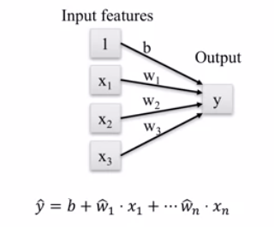

Fig. 1: Linear Regression

**Linear model for classification: Logistic Regression**

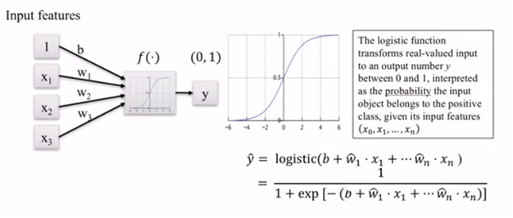

Fig. 2: Linear model for classification: Logistic Regression

**Logistic Regression for Binary Classification**

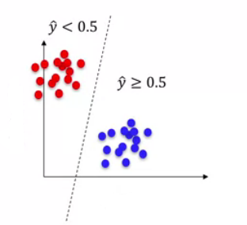

Fig. 3: Logistic Regression for Binary Classification

* **Hour: 2.0-3.0**

(It is Not a Group Task, Try Individually)

**Task 01:** Mark 10 **Time: 50 minutes**

Write a code for classification using “Social_Network_Ads” data file and draw the ROC (receiver operating characteristic) curve from the actual *y* and predicted *y*.

**Evaluation Process (VIVA):** You have to explain your program to the Lab Instructor

**---End---**